210905346_gauri@prg:~/Desktop/210905346$ python3 sample.py
Enter Length : 4
Enter Breadth : 2
Area : 8
Enter Number 1 : 3
Enter Number 2 : 4
a : 4 b: 3
Enter a Number : 3
Odd
Enter Number 1 : 3
Enter Number 2 : 4
Enter Number 3 : 1
4 is greater
Enter Number : 3
Enter Number : 4
Enter Number : 5
Enter Number : 1
[3, 4, 5, 1]
[3, 4, 5]
[5, 4, 3]
(1, 3, 5, 7, 9)
(2, 4, 6, 8, 10)
(12, 38, 56, 78)
-21
-93
Even Count : 2 Odd Count : 4
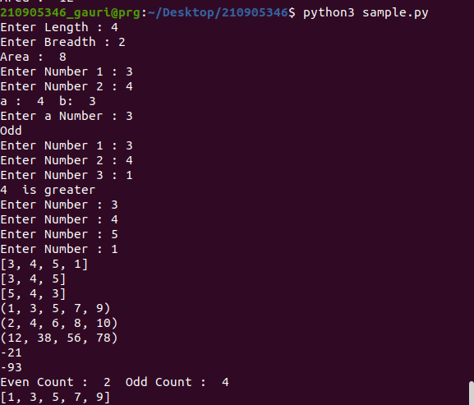
[1, 3, 5, 7, 9]

